**18/5/2020 -Certification course on Machine Learning Onramp**



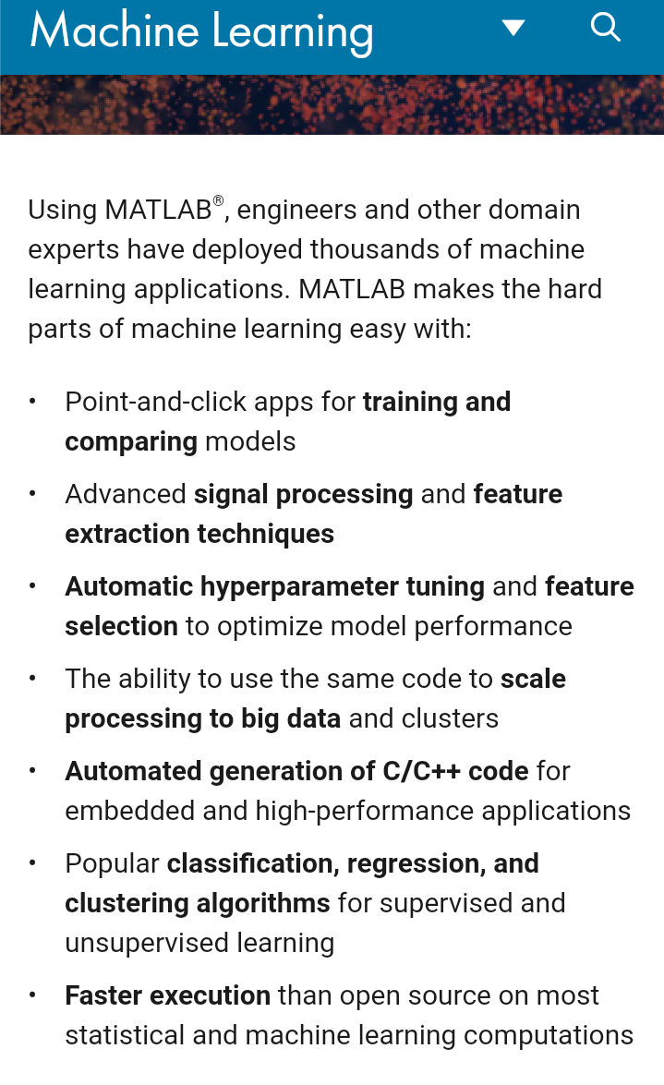

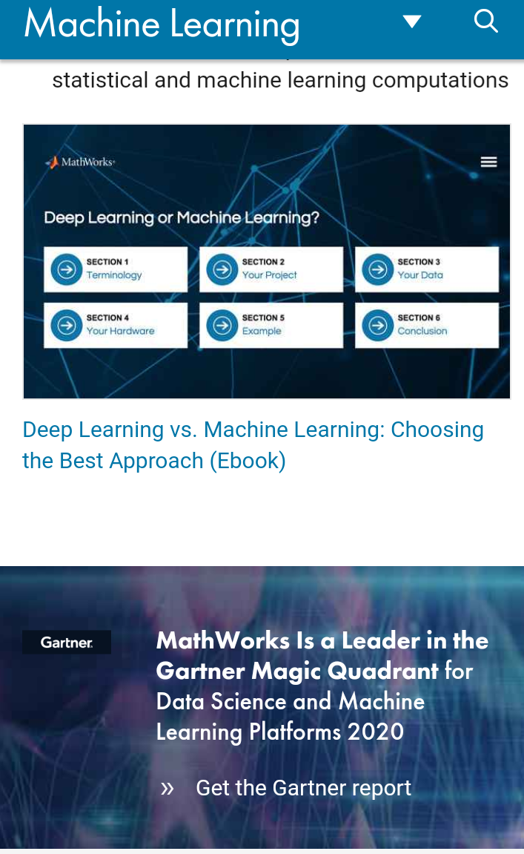

In this course there was a Practical machine learning methods for classification Problems. It has also included how to build a simple model to perform a classification task.

